Farnborough SN Urban event

Sun 20 August, 2017
Near: Farnborough
Level of event: C
Type of event: Race, Urban

Directions / Parking
Parking at Farnborough Leisure Centre (in Sulzers Roundabout) - GU14 7LD is the nearest postcode. Please follow signs to park in Westmead House car park, to leave space regular users outside the leisure centre. There is a charge of 50p/hour; machines in car parks. Tall vehicles (over 7ft 6in / 2.3m) will need to park directly outside the leisure centre.
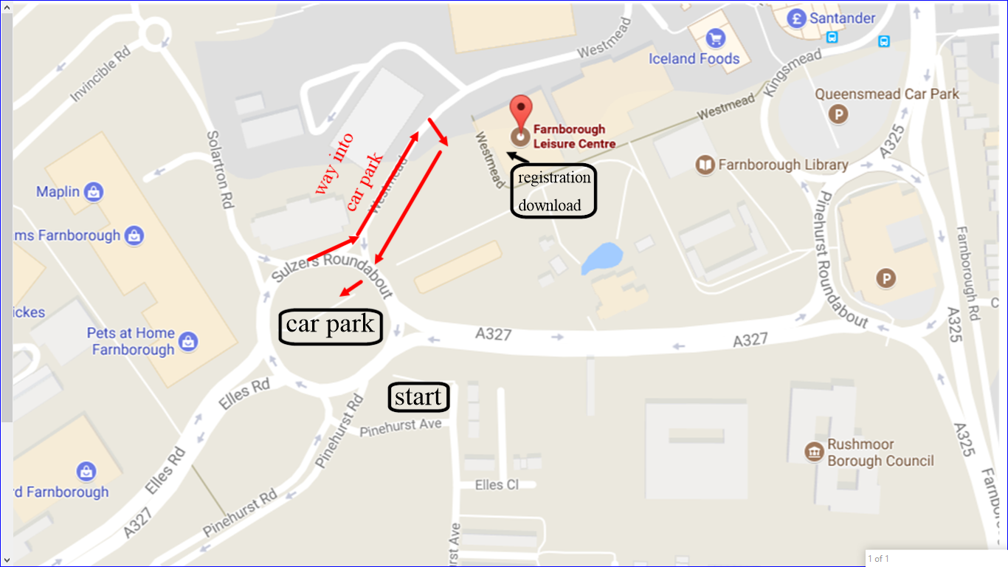

Course Information
A | Men Open, Mens Vets (M40+), Men SuperVets (M55+), Women Open | 6.1 km
B | Mens UltraVets (M65+), Womens Vets (W40+), Women SuperVets (W55+) | 4.9 km
C | Mens Junior (M16-), Womens Junior (W16-), Women UltraVets (W65+) | 3.1 km
D | Children (M/W12-) | 1.8 km
Juniors MUST be 16 or older to run course A or B.
Course D is not guaranteed to be 100% traffic-free. It is restricted to a business park and small housing estates with no through roads, both of which on past experience have minimal traffic on a Sunday morning. Parents should decide whether to shadow their children.
Course C, in addition to the above, includes a pedestrianised shopping centre with some surrounding car parks and access roads. Optimal routes should encounter minimal traffic, but competitors should take extra care in these areas. Indoor areas of shopping centres are out-of-bounds.
Courses A & B, in addition to both the above, include residential, shopping and business areas, with normal unrestricted traffic, which at times may be busy.
For courses A-C certain busy roads with no immediately adjacent pavement have been overprinted with the purple out-of-bounds symbol – please respect this. These courses may also encounter a car boot sale in a covered car park, but any feasible routes will skirt the edge of the sale area.
All competitors should remember that any urban area includes risks such as traffic, pedestrian crowds, street furniture etc, and take appropriate care.
The area is predominantly paved / tarmac, with some areas of grass. Shorts permitted.

Map
ISSOM. Scale 1:4000. Surveyed 2014, and updated 2017. Printed on waterproof paper, sized A3 for courses A & B and A4 for C & D.

The map indicates a contour interval of 2.5m, but there are no contour lines actually on the map! The majority of the terrain is relatively flat, but it rises in the SE corner by around 5-10m; and for the A & B courses the western half of the map is centred around a similar size hill.

There is no legend on the map. Please ensure you are familiar with the ISSOM “forbidden to cross” symbols: linear vegetation, fence & wall; and the area symbols for buildings, “olive green” and purple overprint. (https://www.maprunner.co.uk/map-symbols/).

Control descriptions are printed on the front of the map: pictorial for courses A-C and text for course D.

Entry on Day Details
Limited entry on the day, whilst maps available.
Adults £10 (£12 non-BOF member)
Junior £6 (£8 non-BOF member)
Timing is by Sport Ident electronic punching. SI-cards are available to hire on the day for £1.

Registration & Start Times
Registration 09:45 - 11:15
Start times 10:00 - 11:30
Courses close 13:30
Please collect a race number from registration before going to the start. This is just to identify you as a competitor, so any number will do. If you have any medical condition you would want someone treating you to be aware of, please add appropriate details to the back of the number.
There is one start for all courses, approx 50m from car park, and 200m from registration/download. There are no allocated start times; turn up and go.
There are no blank maps.
Loose controls descriptions will be available at the start, on waterproof paper.
Courses A-C finish near download. Course D finishes adjacent to the start and there will be helpers on hand to escort runners to download.

Facilities
Registration and download are in Farnborough Leisure Centre, where toilets and a cafe are available. A key drop will be available at registration. Farnborough town centre is a (very) short walk.
First aid kit at registration. Nearest A & E is Frimley Park Hospital, 3 miles.

Contacts / Officials
Organiser: Hannah Gray (07876 715792 on the day)
Planner: Steve Peacock
Controller: Alan Wallis

Thanks
Thank you to Farnborough Business Park for use of the land for this event.
Also to Rushmoor Borough Council and Farnborough Leisure Centre.

Important Event Information
Safety and Risk: A comprehensive risk assessment will have been carried out by the organiser, but participants take part at their own risk and are responsible for their own safety during the event.
Insurance: Please note that if you have competed in three orienteering events and not joined an orienteering club that is a member of British Orienteering then you are not covered by our public liability insurance.
Privacy: when entering our events your name may appear in the results section of this website or in newspaper reports. Read our data protection page to see how we look after your personal data.

